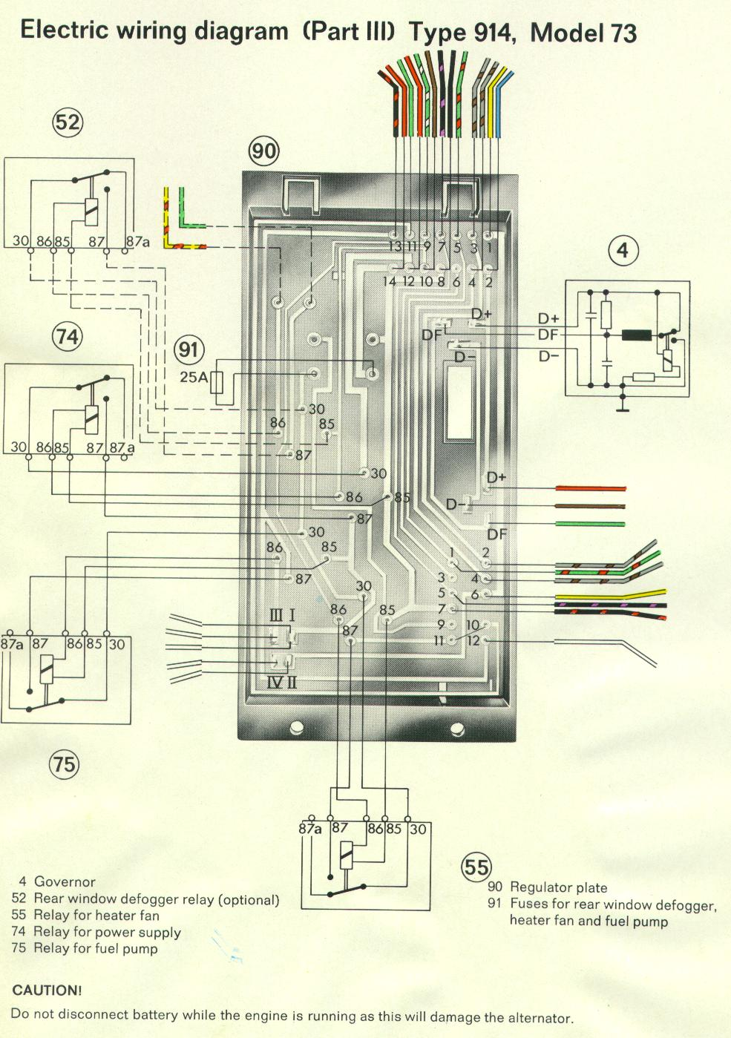 14-pin connector:
1 = yellow from ignition switch”50” (+ in start) to “6” on 12-pin connector (to starter “2”)
2 = lt blue (?) to alt light, from “D+” at voltage regulator and “D+” at alternator (red)
3 = grey/brown from brake light switch “35” (+ from fuse 9), to “2” on 12-pin connector (to back-up light switch “39”)
4 = grey/brown to back-up lights (“58” in tail lamp assembly “14”), from “4” on 12-pin connector (from back-up light switch “39”)
5 = green/red to oil pressure light in combination instrument, from “1” on 12-pin connector (from oil pressure switch “40”)
6 = Not used on ‘73 914 (green/black on ’71, to “86”?)
7 = black/violet to “1”/”G” on tachometer (“22”), from “5” on 12-pin connector (from ignition coil “6”)
8 = black from ignition switch “15” (+ in “run”) via hot side of fuse 8, to power supply relay (“74”), heater fan relay (“55”), and “7” on 12-pin connector (to ignition coil “6”)
9 = green/white from heater fan switch “37” (switched ground), to heater fan relay (55”)
10 = brown to ground point “A” (“82”), from power supply relay (“74”)
11 = green to heater fan (“65”), from heater fan relay (55”)
12 = red (constant “hot”) from battery “1,” to power supply relay (“74”)
13 = black/red to fuel pump (“9”), from fuel pump relay (“75”), and to “12” on 12-pin connector (to supplementary air valve “78”)
14 = red (constant “hot”) from battery “1,” to 25-amp fuse (“91”), to fuel pump relay (“”75”), heater fan relay (55”), and rear window defog relay (“52” [optional equipment])

