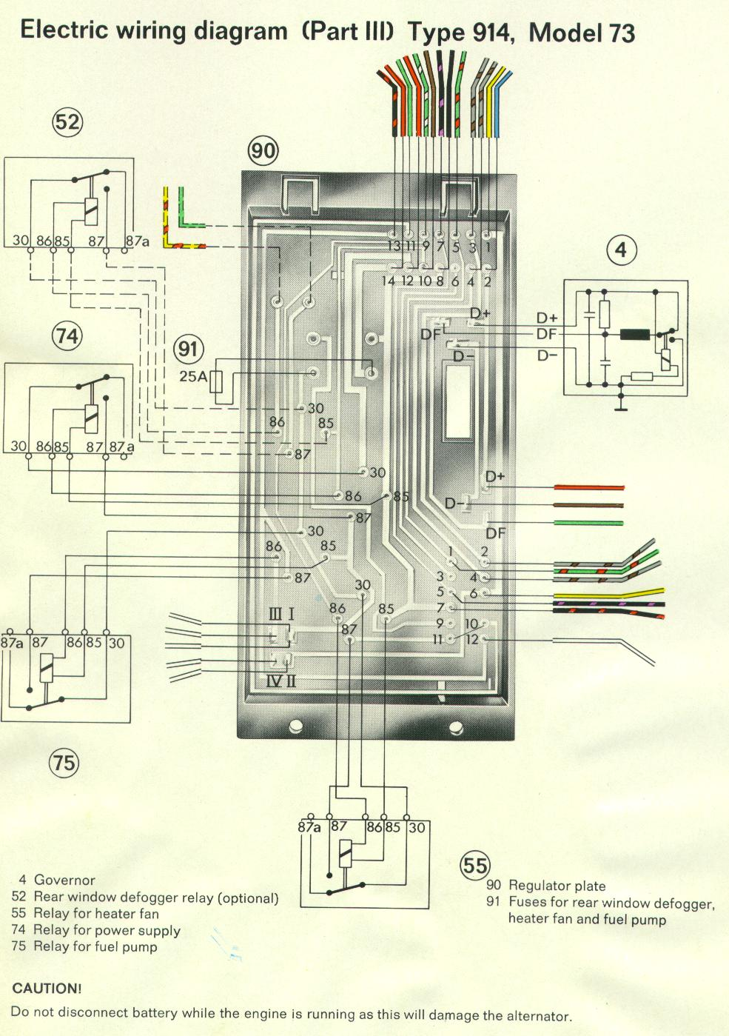 12-pin connector:
1 = green/red from oil pressure switch “40” to oil pressure light in combination instrument (via “5” on 14-pin connector to light on “21” combo gauge)
2 = grey/brown to back-up light switch “39,” from “3” on 14-pin connector (from brake light switch “35” [+ from fuse 9])
3 = Not used on ‘73 914 (on ’71, green/black from “42”?), connects to “6” on 14-pin connector (also not used on ’73—on ’71 green/black to “86”?)
4 = grey/brown from back-up light switch “39,” to “4” on 14-pin connector (to back-up lights [“58” in tail lamp assembly “14”])
5 = black/violet from ignition coil “6,” to “7“ on 14-pin connector (to 1”/”G” on tachometer [“22”])
6 = yellow to starter “2,” from “1” on 14-pin connector (from ignition switch “50,” + in start)
7 = black/red from ignition coil “6,” to “8” on 14-pin connector (black, to ignition switch “15” [+ in “run”] via hot side of fuse 8, power supply relay [“74”], heater fan relay [“55”])
8 = None (blank)
9 = Not used (connects to “empty” fuse holder, to “8” on 14-pin connector [black from ignition switch “15” + in run, see notes for pin “7” above)
10 = No pin at plug, to “11” at 14-pin plug (green to heater fan (“65”); “jumper” [green] connection to pin 11 (to heater fan relay [55”]
11 = No pin at plug, to heater fan relay (“55”), also “jumper” [green] connection to “10” (see above) (on to “11” at 14-pin plug [green to heater fan “65”])
12 = white to supplementary air valve “78,” and to 13 on 14-pin plug (black/red to fuel pump [“9”], from fuel pump relay [“75”])

